Why Do We Use HAVING with Aggregate Functions?

-In SQL, there's a key difference between WHERE and HAVING:

|  |  |  |
| --- | --- | --- |
| **Clause** | **When is it used?** | **Can use aggregate functions?** |
| WHERE | **Before** grouping | No |
| HAVING | **After** grouping | Yes |

The Main Reason:

HAVING is used to filter grouped/aggregated results, while WHERE is used to filter individual rows before grouping.

Example:

Suppose you have an employees table with:

* 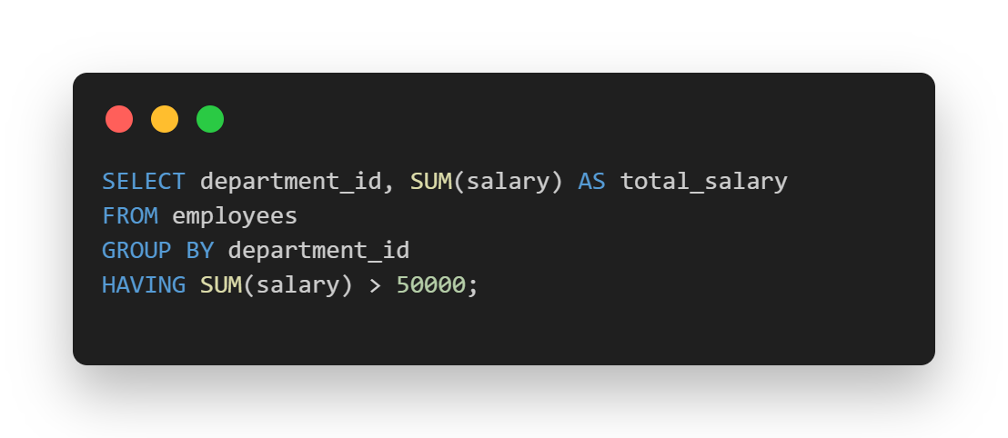department_id
* salary
* GROUP BY groups employees by department.
* SUM(salary) calculates the total salary per department.
* HAVING filters those groups based on the result of the aggregation.

Why Not Use WHERE Instead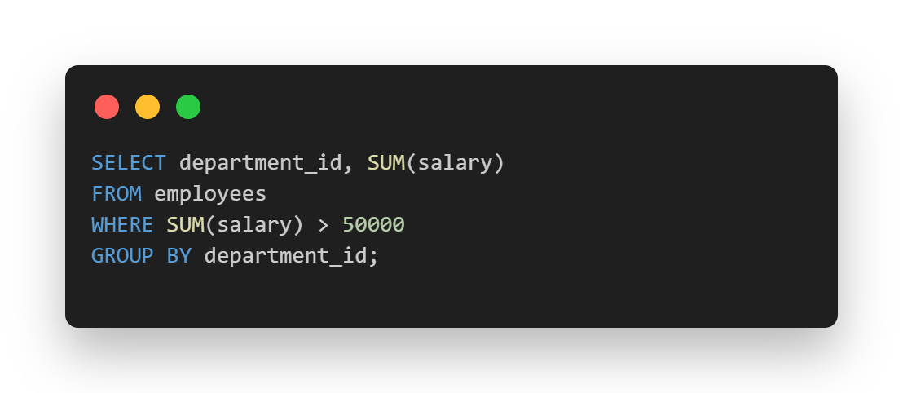

This will give an error because SUM(salary) is **not known** in the WHERE clause — aggregation hasn't happened yet.

**At Least :**

|  |  |
| --- | --- |
| **Purpose** | **Use** |
| Filter rows before grouping | WHERE |
| Filter grouped results | HAVING |